Bradley Lamitie Active Learning 1

**Description**:

The main intent of this active learning module is to solidify our understanding of how to configure a small network. This is achieved through repeating the steps we followed in class to configure an identical network in Cisco Packet Tracer.

**Topology**:

*** ALL SUBNET MASKS ARE 255.255.255.224 ***

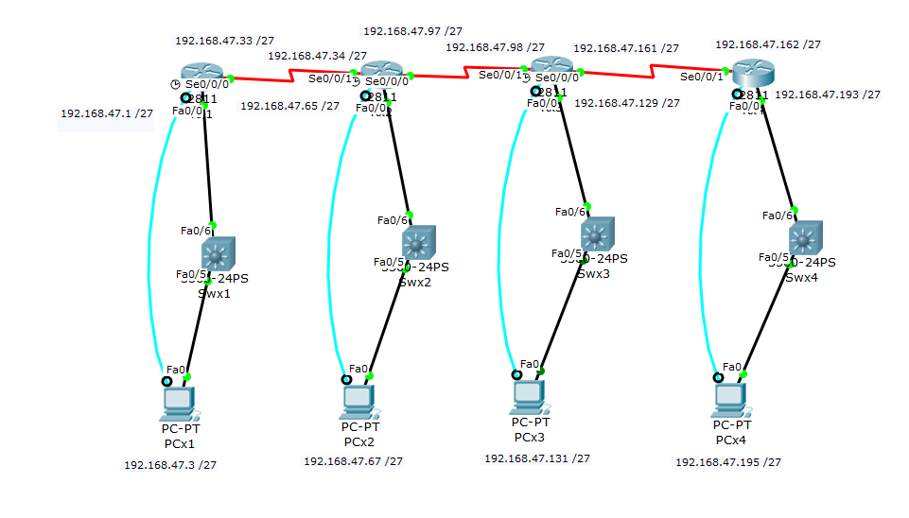

**Configuration Syntax:**

(All replaceable parameters are in italics)

|  |  |
| --- | --- |
| **Syntax** | **Description (in my own words)** |
| enable | Enter privileged mode |
| config | Enter configuration mode |
| terminal | Configures from terminal |
| Hostname *desiredHostName* | Renames the router |
| Enable password *cisco* | Sets the privilege mode password to be ‘cisco’ |
| Ctrl + Z | Returns to privileged mode |
| Logging synchronous | Makes it so that the console does not create messages while you're typing a new command |
| Con line *0* | Enters configuration mode for console line 0 |
| Password *cisco* | Sets the console line password to be ‘cisco’ |
| login | Makes logging in required when accessing router from pc through console |
| Interface *f0/0* | Sets the configuration mode to configure fast ethernet 0/0 port. |
| Ip address *ipAddress* *SubnetMask* | Configures the ip address and subnet mask for the specified interface |
| No shutdown | Enables the interface |
| Int *S0/0/0* | Sets the configuration mode to configure Serial slot 0/0/0 |
| Clock rate *64000* | Sets the clockrate of the DCE interface to be 64000 |
| Show interfaces | Shows the interfaces and their stati |
| Show ip route | Shows the ip routing table |
| exit | Exits configuration mode |
| disable | Leaves privileged mode |
| Ip route *networkAddress* *SubnetMask* *ClosestUsableIPAddress* | Creates a route in the routers routing table |

**2.C**

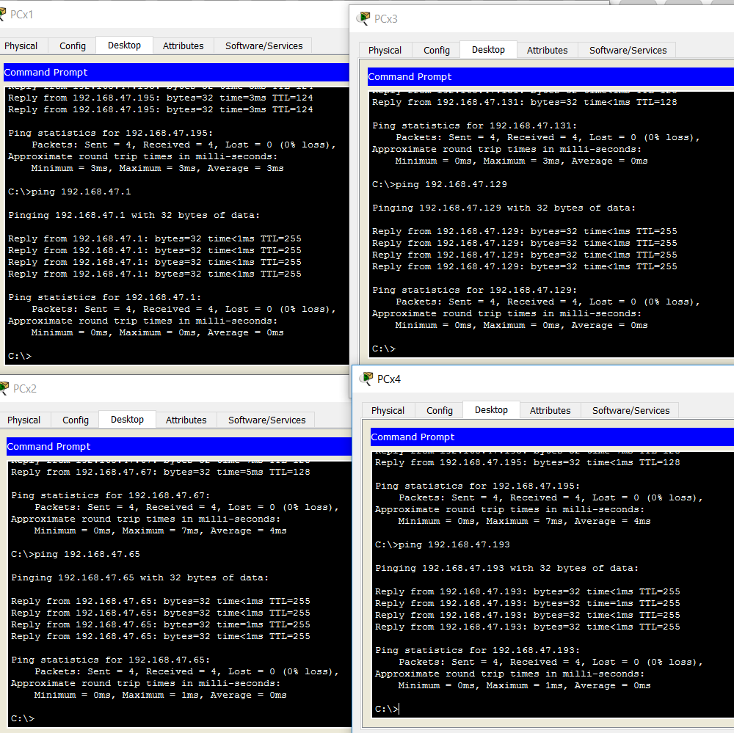

**2.E**

Show ip full connectivity (All networks are accessible)

USING show ip route

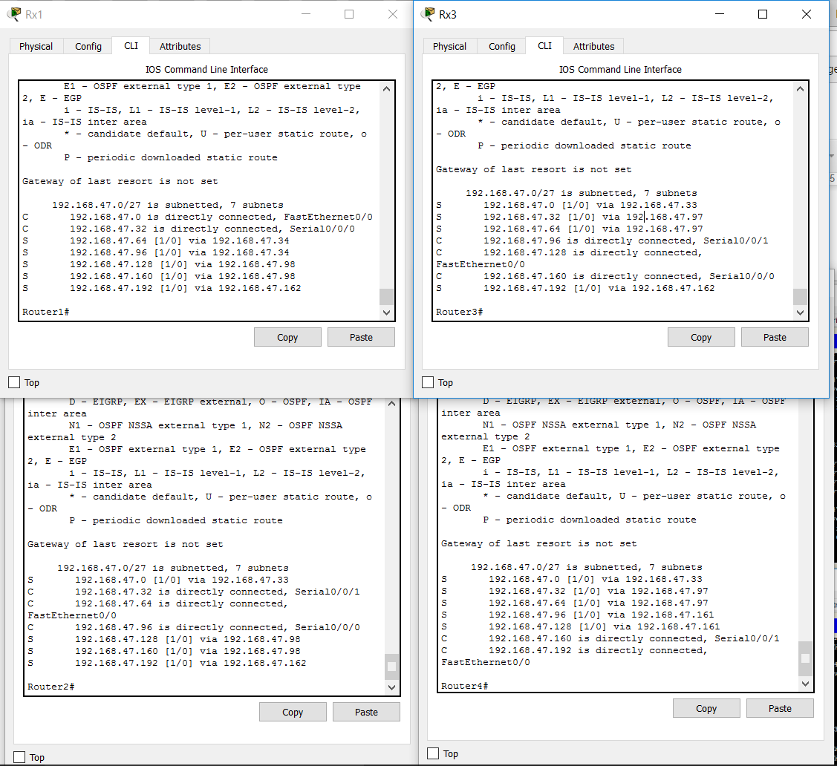

**USING show interfaces**

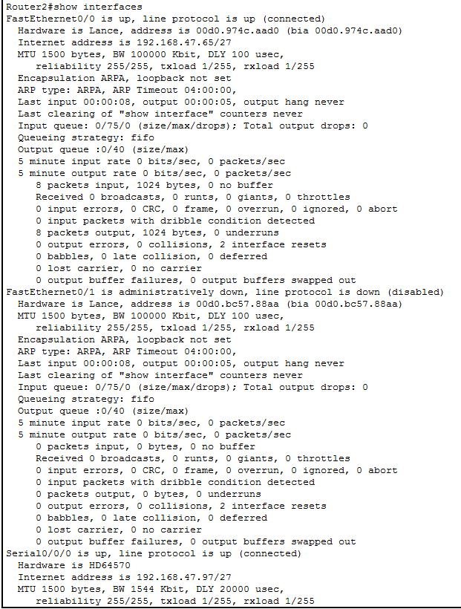

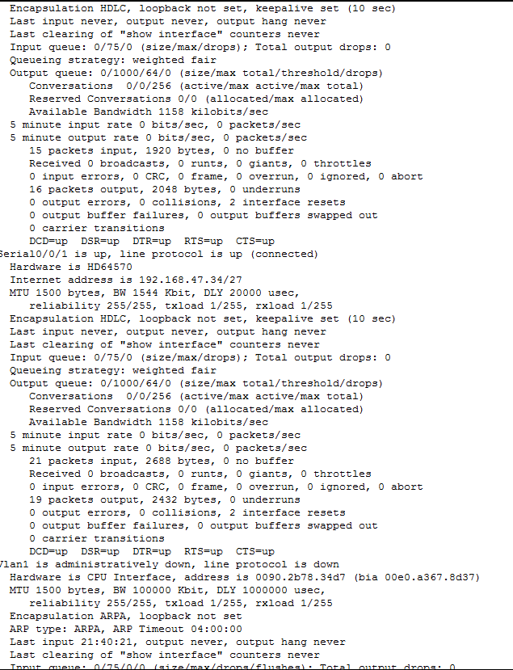

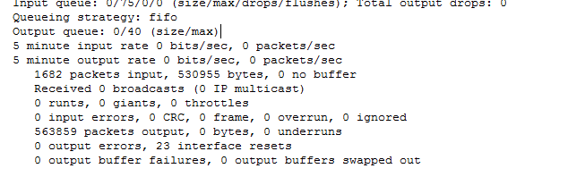

**Troubleshooting Syntax:**

I didn't have any problems this time, but i did use the ? to help locate the command to require login.

**What Worked, What Didn’t?:**

Everything worked fine.